Re-dedication of Woollacott Square

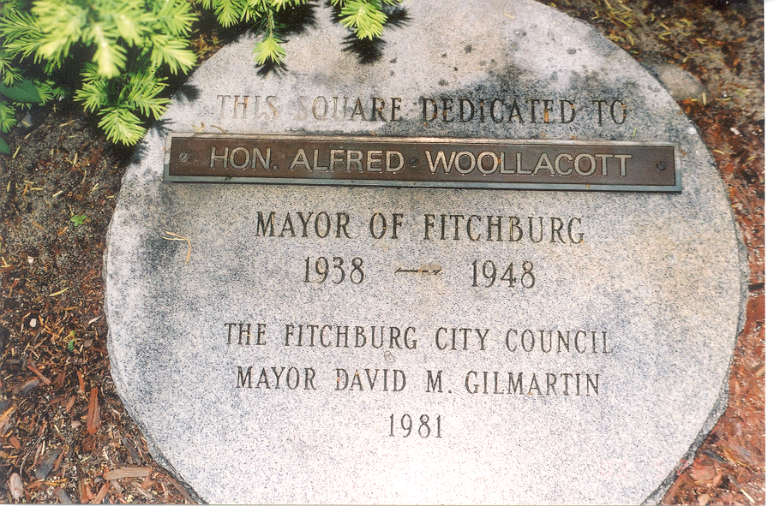

26 May 2015

By Alfred Woollacott, III, grandson
In 1981 the square at the intersection of Main and Pritchard Streets was named “Woollacott Square” in honor of Alfred Woollacott, Mayor of Fitchburg from 1938 to 1948. The Sentinel reported the dedication as follows:
THE HONOR GIVEN TO WOOLLACOTT
FITCHBURG - The area at Main Street and Pritchard Street took new significance recently when people representing government and business joined friends and relatives to celebrate the dedication of "Woollacott Square" in honor of Alfred Woollacott who served as Mayor of the city of Fitchburg from 1938 to 1947.
Mayor Alfred Woollacott witnessed an outpouring of genuine praise and gratitude reflecting his many years of service to the city of Fitchburg.
The program was sponsored by the Fitchburg In town Business Association in response to the petition that was filed by Mayor David M. Gilmartin and approved by the City Council to name the newly created pedestrian area in honor of Mayor Woollacott.
Henry Dextraze, President of the City Council, extended the best wishes of the city of Fitchburg. George Snow, President of F. I. B. A., spoke of Woollacott's willingness to become involved in the business of the city. As a former retailer and owner of Ritter's, his commitment and interest in Main St. set a wonderful example. Richard J. Moriarty, Executive Director of Pride Inc., called Mr. Woollacott a "Renaissance Man". The Sundailers presented musical selections in honor of the occasion. Following the dedication Mayor Woollacott was treated to a special tour of the restored Whitney Opera House in Pritchard Plaza by Developer David Donahue.
*****
Alfred was in his 89th year when The Square was named in his honored. Below is a photograph with Alfred (1892 – 1986), his middle and still living son, Paul (b. 1925), his niece, Edith Mae (Woollacott) Flynn (1925 -1983), Paul’s son Russell (b. 1950), and grandson, David Austin Woollacott (1978 -2003), Alfred’s sister-in-law and her husband, Ruth (Russell) Woollacott (1901 -1986) and his brother Elon Woollacott (1904 – 1983), respectively, and his “baby sister”, Edith (Woollacott) (Russell) Abbott (1905 – 2008).
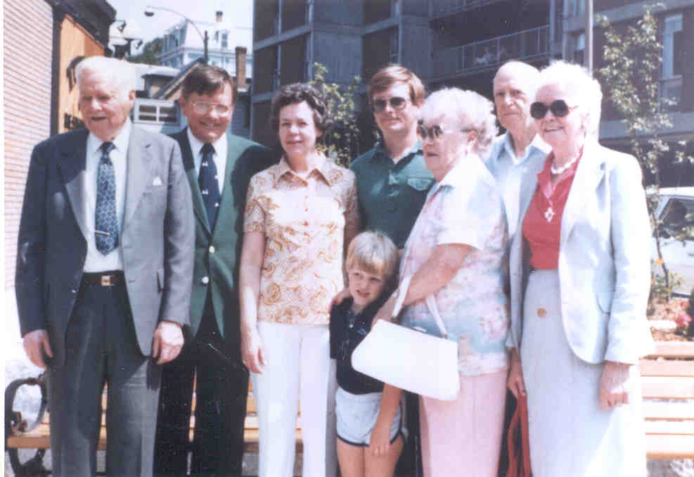

Alfred Woollacott was born in West Fitchburg on 18 May 1892, the fourth child of what would be eleven children of John and Nora (Newcombe) Woollacott. Alfred, like many Fitchburgers of the time, was a first generation of immigrants. His father, at the age of 17, left his village of Atherington, Devonshire, England in 1880 for America, leaving behind his parents, two sisters and 50 first cousins. In route his mother died, and his sisters Nora (Woollacott) Newcombe (1860 – 1942) and Mary Ann (Woollacott) Woods (1869 – 1962) and father, Elon (1829 – 1904) followed John to Fitchburg soon afterward. On the 4th of July 1885, John married Nora Newcombe also of Atherington, who had immigrated to Fitchburg in 1872 at the age of 9. The 4th of July was always a cause for celebration at the Woollacott residence on 94 Philips Street in West Fitchburg because of the anniversaries of John and Nora’s wedding and the birth of their newly adopted country.
Below is a June 1909 photograph, taken after church and in front of the Woollacott’s Philips Street home. Front row: Ralph (1900 – 1974), Martha (1896 – 1985), Elon (1904 – 1983), Nora (1862 – 1955), Edith (1905 – 2008), John (1862 – 1966), Ida (1898 -1916) and Fanny (1902 -1945). Top row: Anne (1894 -1986), John (1886 – 1972), Lena (1888 – 1889) and Alfred (1892 – 1986). Their third child, Emma (1890 – 1893), died when Alfred was 9 months old.

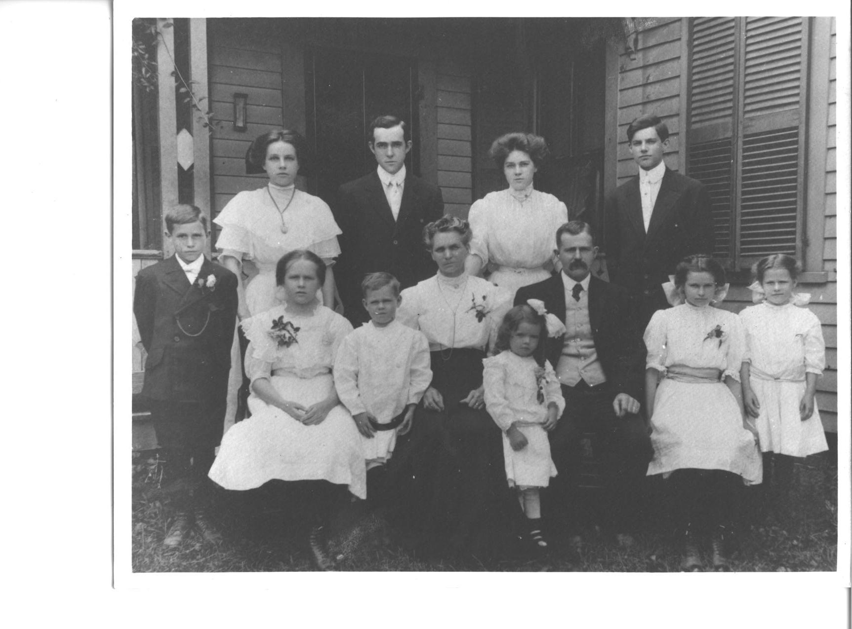
Alfred’s would first job was tending cows in West Fitchburg for 5 cents a day. Among his keepsakes at the time of his death was a cow bell he kept to remind him of that first job. Below is a photograph of Alfred and his sister, Anne, taken around the time when Alfred tended cows.

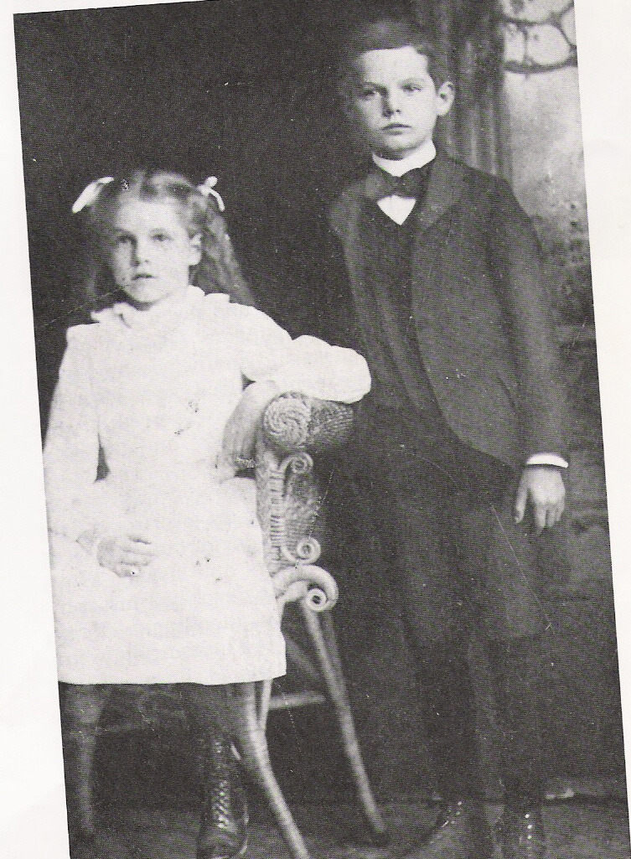
He graduated from Fitchburg High School in 1909 and was accepted at Dartmouth College. He wanted to become a Doctor, but did not matriculate at Dartmouth since he realized it would place a financial burden upon his family. Instead, he continued his work for a nickel a day as a florist to help with the family finances. Below is Alfred, perhaps in his early 20s
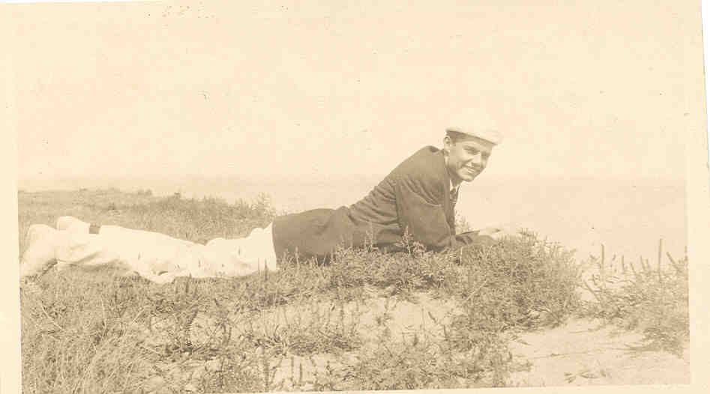
Alfred would realize his desire to become a doctor as he served as a medic while in France during The Great War, World War I.
After the war he returned home and married in Atlantic Highlands, New Jersey on 5 August 1919 Grace Bray Williams. Below is photograph from the wedding. Grace and Alfred are on the far right. The diminutive man, second from the left, is the Reverend Jerome Wood, Grace’s uncle. Eight years earlier, Reverend Wood married Alfred’s sister, Lena, in Fitchburg, and Grace, a sophomore at the Normal School (now Fitchburg State) was at the wedding. I do not know when Alfred and Grace first met Alfred, perhaps it was at Lena’s wedding.
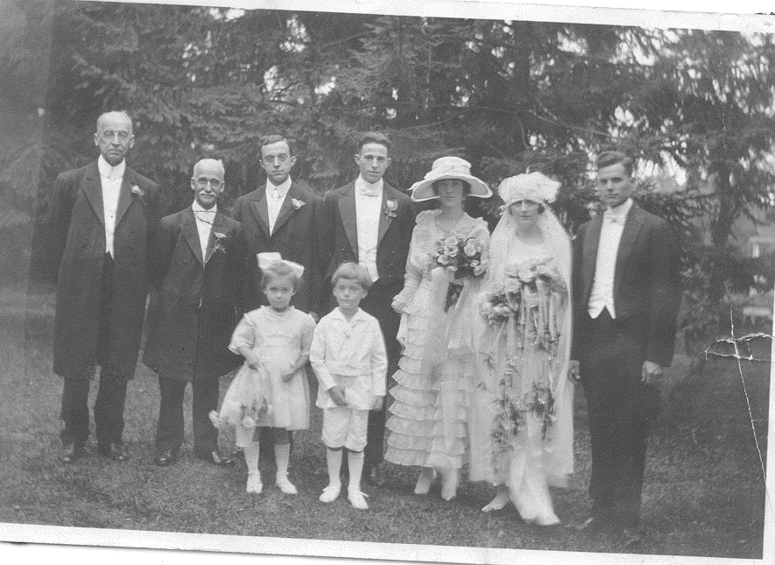
Alfred and Grace would have three children, Alfred Jr. (1922 – 1967), Paul (b.1925) and Evan (1929 – 2014). Grace and Alfred resided at 19 Winter Street for their entire lives, except for a brief period in 1986 when Alfred moved to the Cedar Street Rest Home, shortly before his death. Alfred worked at Ritter’s for Flowers, and would until his retirement in the late 1960s.
He was active in local politics, and in 1938 he ran for Mayor and won. The headlines from Sentinel read: WOOLLACOTT FIRST W. FITCHBURGER ELECTED MAYOR
Below is Alfred’s father, John, age 76, congratulating Alfred, age 46, on being elected Mayor. John would say ‘it was the proudest day of his life’.
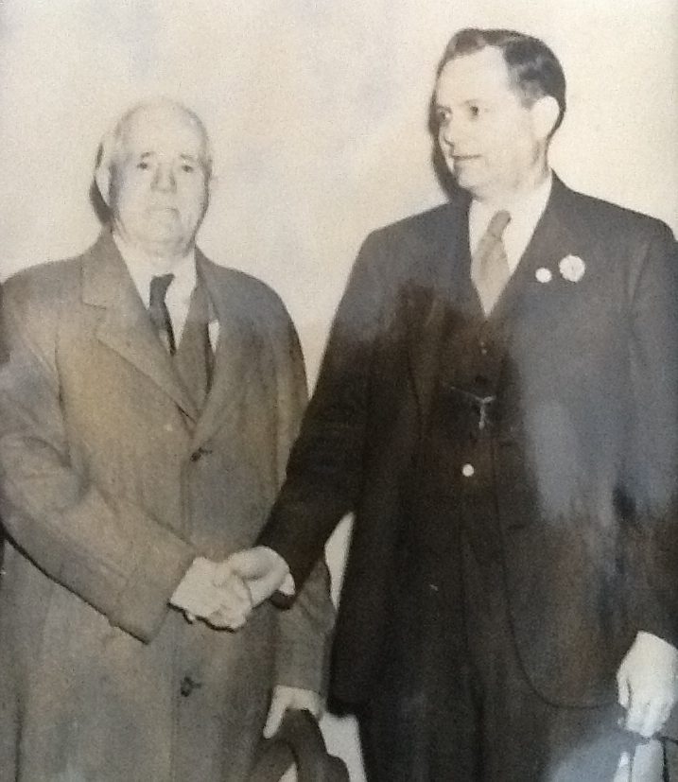

In 1940, Alfred ran for a second term and won again.

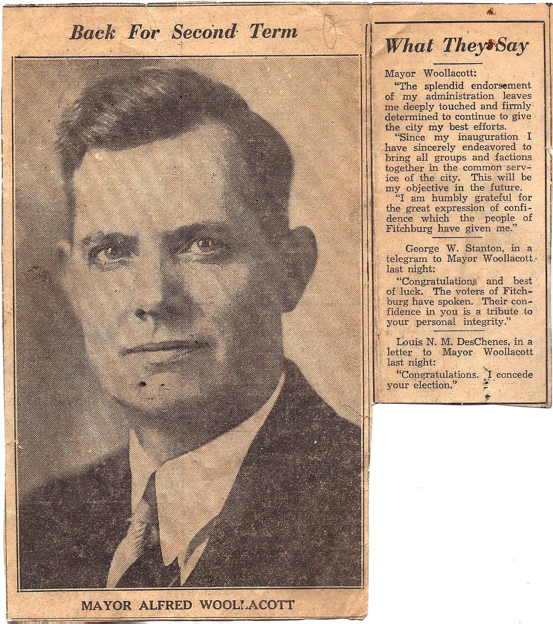
When World War II began, son Alfred Jr. was at Boston University (1939 – 1943), while sons Paul, Jr. and Evan were at Fitchburg High, and at B. F. Brown, respectively. Alfred Jr. eventually joined the Army Air Force and Paul the Navy. Below is a photograph of Alfred Jr. visiting his father at the Mayor’s Office.
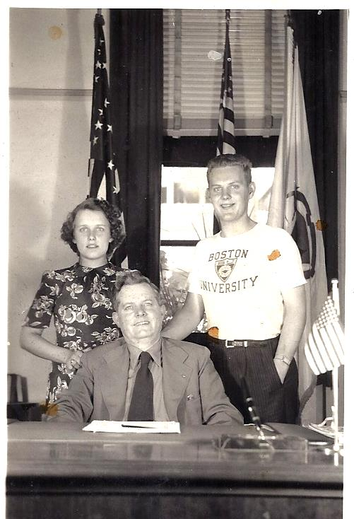
And below is John, second from the left and Alfred with his sons, Evan and Paul, in the plaid jackets in front.
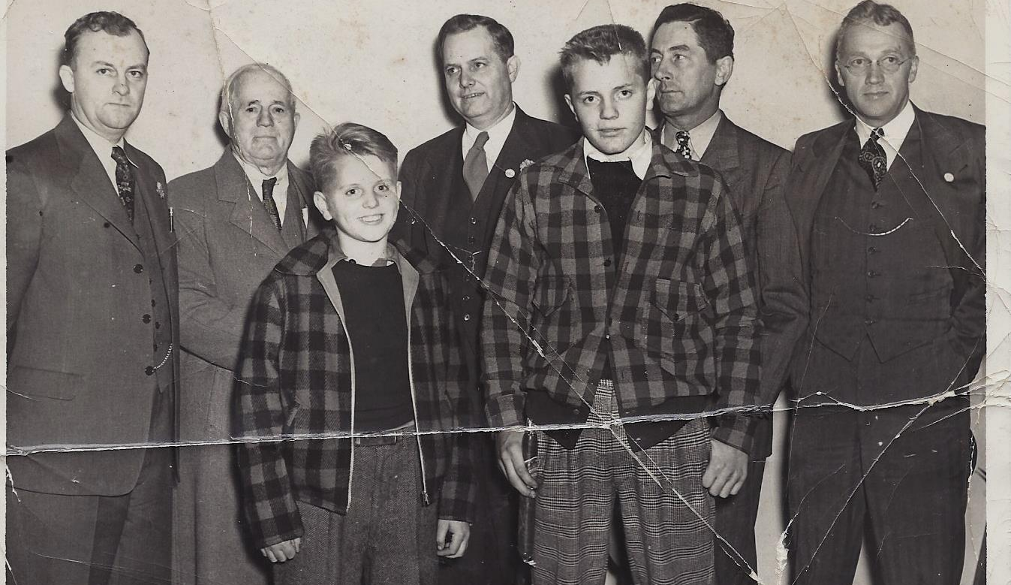
In 1942, Alfred ran against Philip J. Philbin of Clinton for the House of Representatives and lost by a slim margin, remarkable given that Alfred was a Republican running against strongly entrenched opponent in a Democratic district. 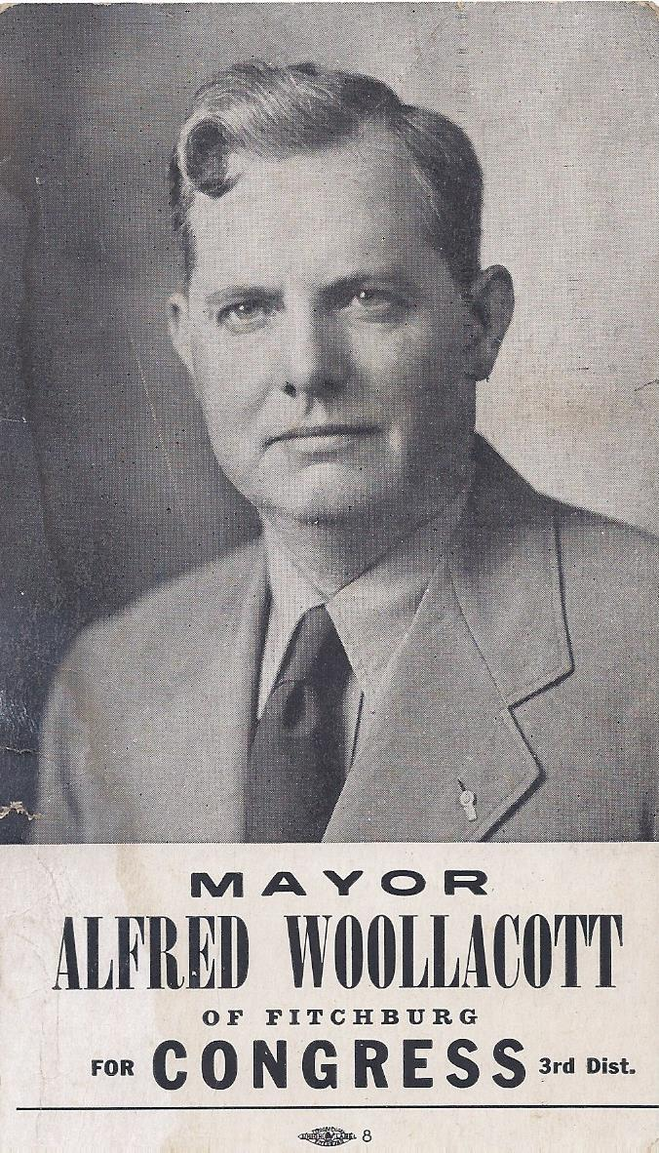
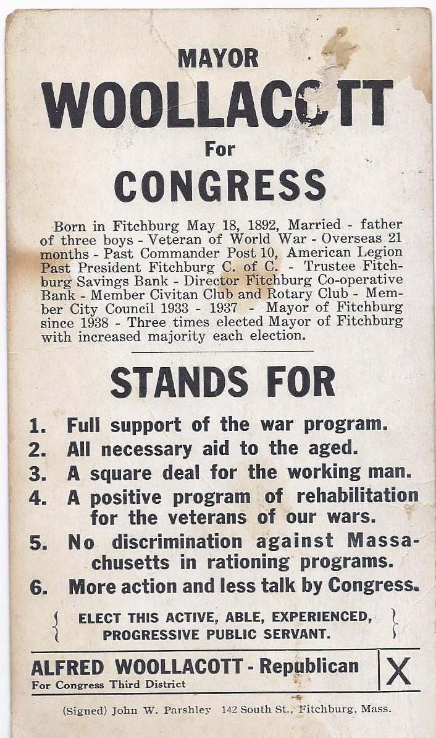
Below is a photograph taken just before the Congressional election, which was used to demonstrate Alfred as a ‘family man’. Taken in the parlor of their Winter Street home, Grace is seated, and Alfred Jr, Paul and Evan are clustering near their father. On the mantel between Alfred Jr. and Paul is a photograph of Alfred with his ever present pipe.
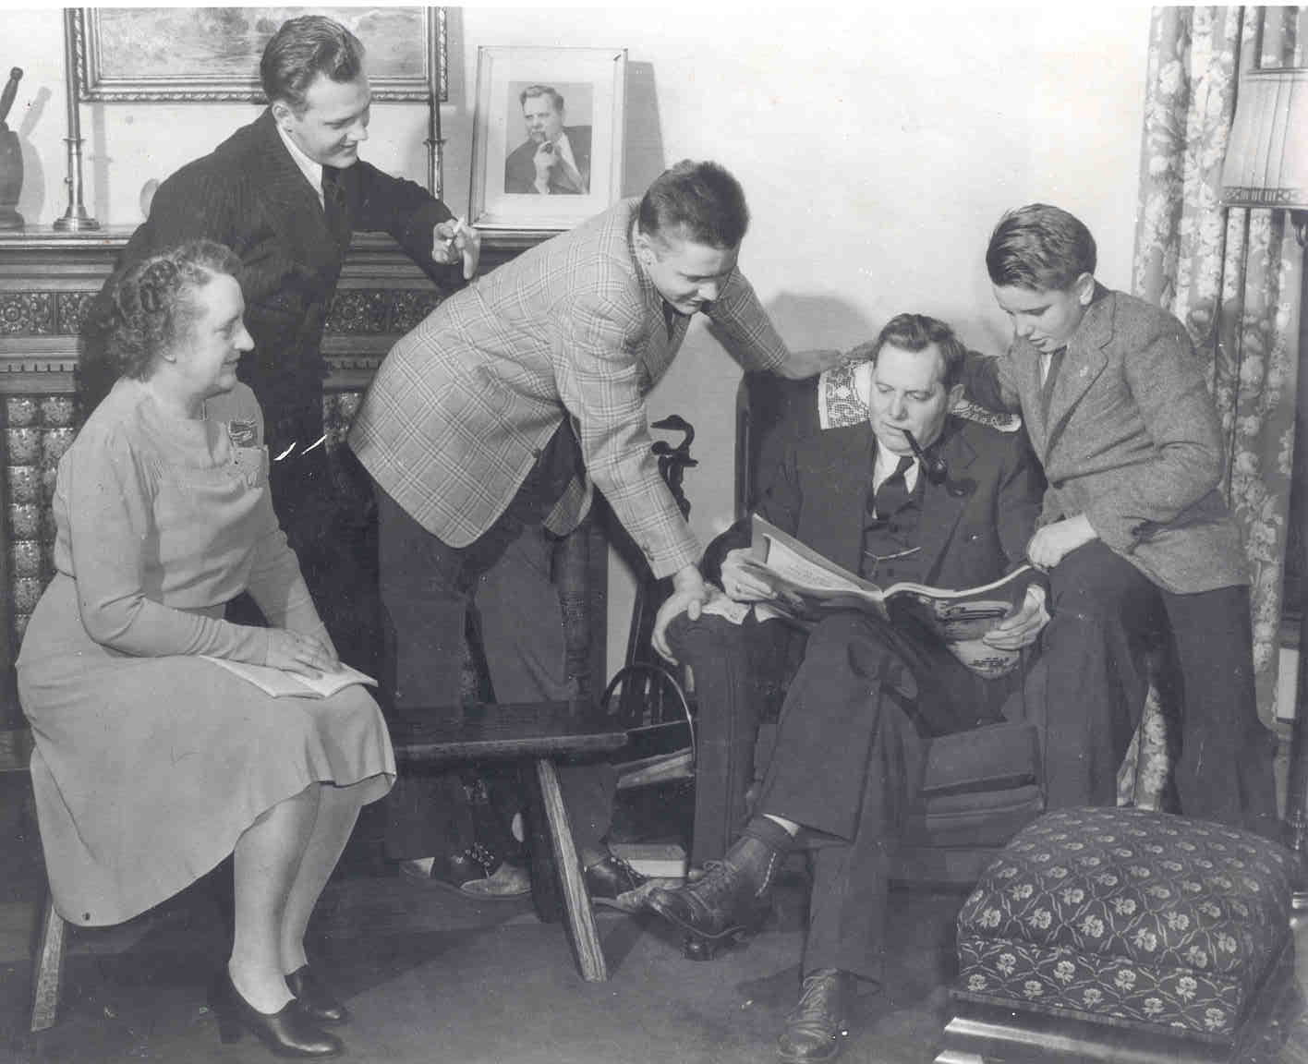
Even though Alfred lost the election, he continued to serve as Mayor of Fitchburg. The Sentinel in Alfred’s 19 August 1986 obituary stated:
During his administrations Woollacott was credited with having built the first railroad underpass for pedestrians in Fitchburg; clearing land for John Fitch Highway; building a system of water mains encircling the city; bringing the General Electric Company to the city; building the Fitchburg Airport; and opening government to Greeks and Finns living here.
He served the city as mayor from 1938 to 1947, and in 1942 was a Republican candidate for Congress against Democratic Philip J. Philbin, losing his bid by 350 votes.
Today, Mayor Bernard F. Chartrand ordered the city flags to be flown at half-mast Tuesday through to Thursday "out of respect for the gentleman (Woollacott) who did so much for the city." Chartrand called Woollacott a "keen, sharp individual" who "knew everything that was going on (in the city) right up until the end".
Woollacott visited Chartrand's office about once a week until three or four months ago. He was known to stroll along Main Street, dressed in a three piece suit, with a tie pin and hat, to visit local businesses.
An old black and white photograph of Woollacott with several Fitchburg boys, including Chartrand, is hanging in the mayor's office. Chartrand, like many other youngsters in the photo, was a "neighborhood mayor" at that time.
*****
Below is a Christmas card from the Mayor during his last term in front of his Winter Street home.
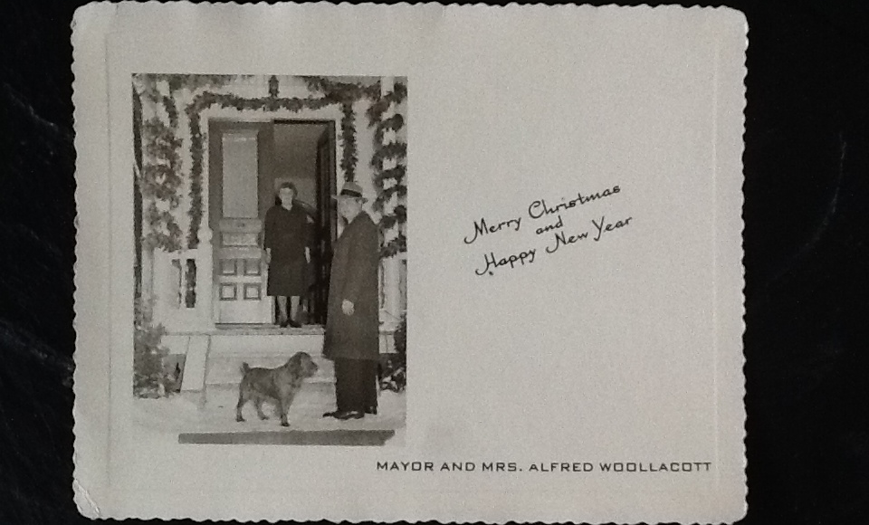

Alfred continued to be active in Fitchburg after his public life. He served on several bank boards; the Fitchburg Mutual Insurance Company, the Burbank Hospital and the Fitchburg Historical Society Boards. His wife Grace was as active as Alfred at the Hospital - she was a charter member and second president of the Burbank Hospital Guild and for many years assisted the late Grace Gummo, superintendent of the Fitchburg Training School for Nurses.
Below is a photograph of Alfred and Grace in their twilight years.
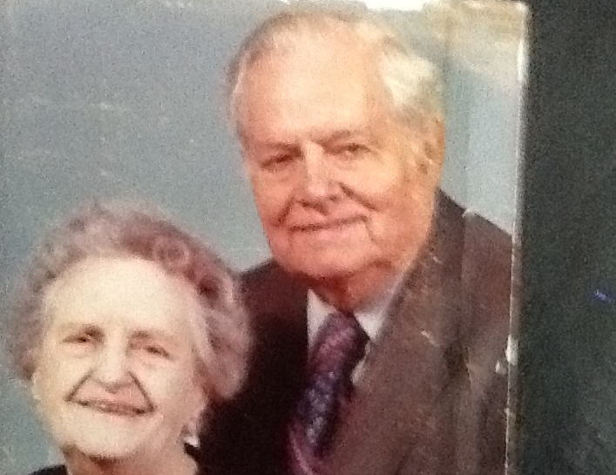
Grace would die at the Burbank Hospital on 15 January 1980. Her obituary from the Sentinel on 16 January 1980 reads:
MRS. WOOLLACOTT; MAYOR'S WIFE - DEAD AT 88
FITCHBURG - Mrs. Grace (Williams) Woollacott, 88, wife of Alfred Woollacott, former Fitchburg mayor, died Tuesday in Burbank Hospital.
Mrs. Woollacott resided at 19 Winter St.
Born in Navesink, N.J., July 9, 1891, she was the daughter of John E. and Carrie (Bray) Williams and lived in this city since 1919.
Mrs. Woollacott was valedictorian of her graduating class from Atlantic Highland High School, H.J. in 1910 and was secretary of the graduating class of Fitchburg Normal School in 1914. She taught in schools in New Jersey, Lunenburg and Fitchburg.
Mrs. Woollacott was a member of the Christ Episcopal Church. She was a charter member and second president of the Burbank Hospital Guild and for many years assisted the late Grace Gummo, superintendent of the Fitchburg Training School for Nurses.
During World War II, Mrs. Woollacott served as chairman of the Red Cross program for Fitchburg prisoners of war. She also served on the Girl Scout Council; was a member of Hastings Hall board of directors and was a member of the Fitchburg Women's Club.
She was a past Worthy Matron of Lady Emma Chapter, Order of Eastern Star and Past Deputy Grand Matron, O.E.S.
Besides her husband she leaves two sons, Paul Woollacott of Fitchburg and Evan W. Woollacott of Simsbury, Conn.; a sister, Susan H. Healey of Fitchburg; eight grandchildren and nine great-grandchildren. Another son, Alfred Jr. served in the Air Corps during World War II, with 30 missions over France and Germany, was killed in action. [Sic: He was not killed in action, he died 4 November 1967 in St. Petersburg, FL - AW3]
Funeral services will be held Thursday at 11 a.m. in Christ Episcopal Church, 569 Main St. The Rev. Samuel W. Hale Jr., rector, will officiate. Interment will be in Forest Hill Cemetery
*****
Alfred continued on without his beloved wife of over 60 years. Below is a photograph of Alfred taken at Easter 1985, in which he appears still full of life. He would leave us seventeen months later. In his hand is an impatient plant; his love of flowers will always be eternal.
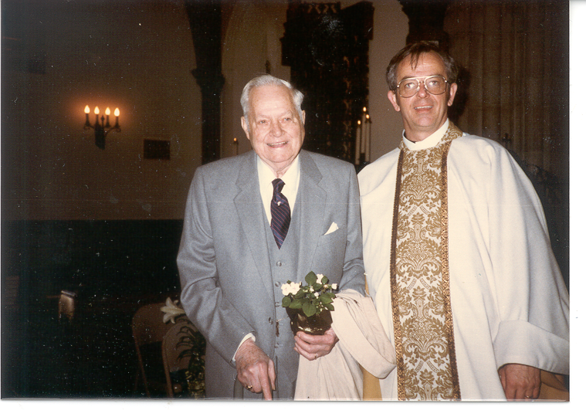
On 18 August 1986 at age 94 Alfred died. The Sentinel the following day wrote Alfred’s Obituary, which reads:
FORMER MAYOR WOOLLACOTT, 94, DIES
FITCHBURG MOURNS LOSS OF CITY LEADER
FITCHBURG Alfred Woollacott, 94, of 19 Winter St., who served as mayor of Fitchburg for five consecutive terms in the 1930's and 40's, died Monday in Burbank Hospital
In active years, Woollacott claimed to have "held every job in town" from mayor, city councilor, acting fire chief, acting police chief, and acting school superintendent, to president of the Chamber of Commerce, Historical Society and Burbank Hospital, and a director of two banks.
During his administrations Woollacott was credited with having built the first railroad underpass for pedestrians in Fitchburg; clearing land for John Fitch Highway; building a system of water mains encircling the city; bringing the General Electric Company to the city; building the Fitchburg Airport; and opening government to Greeks and Finns living here.
He served the city as mayor from 1938 to 1947, and in 1942 was a Republican candidate for Congress against Democratic Philip J. Philbin, losing his bid by 350 votes.
Today, Mayor Bernard F. Chartrand ordered the city flags to be flown at half-mast Tuesday through to Thursday "out of respect for the gentleman (Woollacott) who did so much for the city." Chartrand called Woollacott a "keen, sharp individual" who "knew everything that was going on (in the city) right up until the end".
Woollacott visited Chartrand's office about once a week until three or four months ago. He was known to stroll along Main Street, dressed in a three piece suit, with a tie pin and hat, to visit local businesses.
An old black and white photograph of Woollacott with several Fitchburg boys, including Chartrand, is hanging in the mayor's office. Chartrand, like many other youngsters in the photo, was a "neighborhood mayor" at that time.
Born in this city May 18, 1892, to John and Nora Woollacott, Woollacott was, as a young boy, a nickel a day cowherd and by the 10th grade was making a nickel an hour as a florist's helper after school. After graduating from Fitchburg High School in 1909, he worked full time at Ritter's Flower Shop with a specialty in flower arranging learned in courses taken in New York with the world famous florist, Max Schling.
Woollacott was the owner of Ritter for Flowers during his administrations as mayor, and operated the florist business and city affairs, mornings, from his shop and afternoons, at City Hall.
The FTD florists' use of containers for flowers today, originated with Woollacott in this city when he first presented hospitalized children with floral arrangements, in toys with attached balloons. He was past president of the New England branch of the Florist Telegraph Delivery (FTD) Association.
During World War I, Woollacott served in the Medical Corps in France. He was a past commander of Post 10 American Legion, a member of Barracks 951, World War I veterans, and member of Lt. Lawrence S. Ayer Post, Veterans of Foreign Wars. He was also a member of the former Civitan Club and the Rotary Club.
He served as chairman of the board of the Family Federal Savings & Loan and was an honorary trustee prior to his death.
He was a trustee of the Fitchburg Savings Bank and was a corporator [sic] of the former Worcester North Institution for Savings, now the First Service Bank. He was also a former president of the board of trustees of Burbank Hospital and a current director of the Fitchburg Mutual Fire Insurance Co.
A member of Christ Episcopal Church, Woollacott was the senior past master of the Aurora Lodge of Masons, and a past high priest of the Thomas Royal Arch Chapter 27, and past patron of Lady Emma Chapter 27, Order of Eastern Star; and a member of the Fitchburg Lodge of Elks.
Woollacott was married to the former Grace Williams, who died in 1980.
He leaves two sons, Paul Woollacott of Brewster and Evan W. Woollacott of Simsbury, Conn; three sisters, Lena Thayer and Anne Smith of Fitchburg and Edith, wife of Dr. Celian Abbott of Winchendon; 8 grandchildren; 12 great grandchildren; and many nieces, nephews, grand-nieces and grand-nephews.
A son, Alfred Jr., died in 1967.
A requiem Eucharist will be held Thursday at 10 a.m. in Christ Episcopal Church, 569 Main St., with the Rev. Carl A. Russell Jr. officiating.
Interment will be in the Forest Hill Cemetery.

